France: Custom Internship
France: Custom Internship

Paris, France (Outgoing Program)
Program Terms: | 12 Week Spring #1,  12 Week Spring #2,  12 Week Fall #1,  12 Week Fall #2,  12 Week Summer #1,  12 Week Summer #2,  8 Week Fall #1,  8 Week Fall #2,  8 Week Spring #1,  8 Week Spring #2,  8 Week Summer #1,  8 Week Summer #2
Program Sponsor:

Dates / Deadlines:

Term | Year | App Deadline | Decision Date | Start Date | End Date
8 Week Fall #1 | 2018 | 05/15/2018 ** | Rolling Admission | 09/01/2018 | 10/27/2018
12 Week Fall #1 | 2018 | 05/15/2018 ** | Rolling Admission | 09/01/2018 | 11/24/2018
8 Week Fall #2 | 2018 | 06/15/2018 ** | Rolling Admission | 09/29/2018 | 11/24/2018
12 Week Fall #2 | 2018 | 06/15/2018 ** | Rolling Admission | 09/29/2018 | 12/22/2018
** Indicates rolling admission application process. Applicants will be immediately notified of acceptance into this program and be able to complete post-decision materials prior to the term's application deadline.
Program Description:
Intern in Paris

The City of Lights, as Paris is known, is one of the world's leading business and cultural centers and a fantastic place to intern! Its influence on politics, education, entertainment, media, fashion, science, and the arts make it one of the world's major cities where an internship is sure to enhance your resumé. Placements longer than 3 months are paid in France so it’s a great place to choose for a longer-term assignment. There are placements in most sectors of industry for those with intermediate French skills and we can always arrange language classes for those who want to improve their proficiency. (In some cases, we will admit students with no French skills at all.) France's location in Europe allows you to easily travel to other countries and experience different customs and cultures - take the high-speed ‘Chunnel’ train to London or hop down to Barcelona for some tapas and a weekend at the beach!
Custom Internship in Paris
Your internship placement will be customized to you and your goals in your chosen field. Your resume/CV and cover letter (describing the types of internship placements you would like and the skills you wish to work on during the program) are used to search for your placement. Our placement coordinator in Paris works with a large variety of companies and the organization you are placed with will be determined by many factors including company needs along with your education, experience, and background.
How long is the program?

8 weeks - 6 months
Are placements paid?
Internships 3 months or longer are paid approximately 550 euros/month. Internships less than 2 months are unpaid.

Fees
- 8 weeks -6 months: $3,100
Eligibility
- Participants are required to have completed 2 Semesters of college-level French or the equivalent
- Interns staying for longer than 2 months must be currently enrolled at a university

Program Inclusions
- Custom placement
- On-site Coordinator
- On-site orientation
- Visa assistance (US applicants only)
- ISIC Card (for those currently enrolled in university)
  - Evacuation Insurance (for those currently enrolled in university)
  - Basic Health Insurance (for those currently enrolled in university)

Additional Fees
- Housing
- Airport pickup: $95
- Tour Package: $295
  - City Tour
  - Excursion / Cultural Activity
  - Tour Guidebook
- 3-12 Academic Credits from Truman State University: $650 flat fee
  - 1 credit per 40 hour work week
  - Journal and essay required
- Airfare to/from France
- Visa Fee
- Living expenses

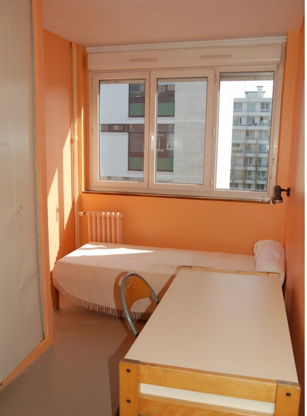

Housing
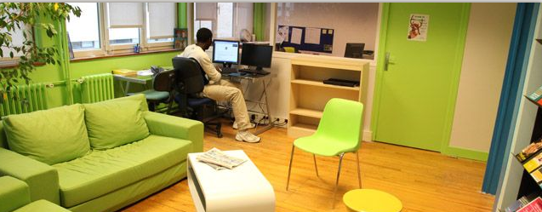
Housing is available in student residences around the city. The main residence is located in the 15th arrondissement, but residences are available throughout the city and other placements are available if an intern is concerned about a long commute. 12 meals/month are included.
Student Residence cost: $1150/month (A security deposit of $300 is required.)
Homestay with breakfast and 3 dinners/week cost: $1350/month (A security deposit of $300 is required.)
Homestay with breakfast only cost: $1100/month (A security deposit of $300 is required.)

Internship Fields
A wide variety of internship fields are available in France! If you don't happen to see your field available, ask us if we can do it
- Architecture
- Art
- Business
- Communications
- Computer Science/ IT
- Economics
- Fashion
- Film and Television
- Health and Social Services
- Hotel/ Hospitality/ Tourism
- Journalism
- Law
- Marketing
- Political Science
Want to see what past participants have done? Check out some Past Internship Placements!

Testimonials

"I LOVE IT! I couldn't have asked for anything better, so thank you." - Tiffany C.
"I am definitely enjoying the internship, it has been such a great experience so far. I've really enjoyed adapting to 'work-life' and delving into the world of business management. I feel very comfortable in the office, the coworkers and boss are great and the whole internship has been really rewarding." - Shihan F.

